Vaginal Atrophy

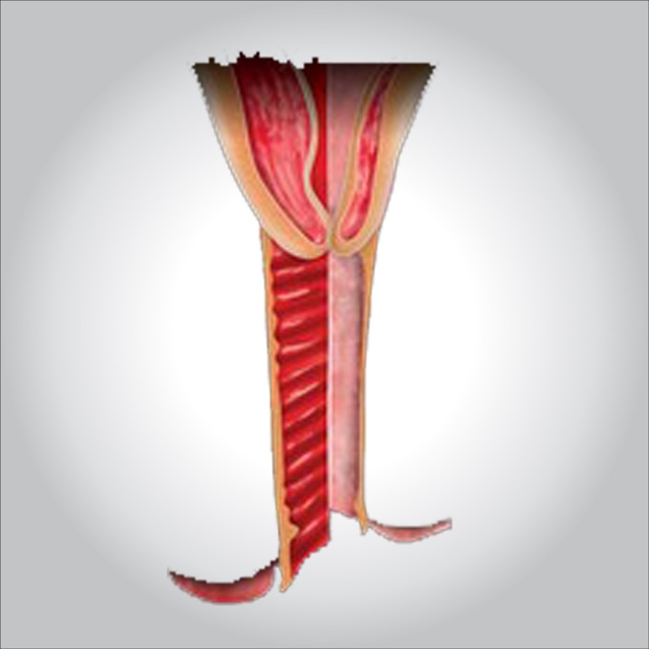

**Vaginal atrophy (atrophic vaginitis) is thinning, drying and inflammation of the vaginal walls that may occur when your body has less estrogen. Vaginal atrophy occurs most often after menopause.**

**For many women, vaginal atrophy not only makes intercourse painful but also leads to distressing urinary symptoms. Because the condition causes both vaginal and urinary symptoms, doctors use the term “genitourinary syndrome of menopause (GSM)” to describe vaginal atrophy and its accompanying symptoms.**

**Simple, effective treatments for GSM are available. Reduced estrogen levels result in changes to your body, but it doesn’t mean you have to live with the discomfort of GSM.**

**Symptoms**

**Genitourinary syndrome of menopause (GSM) signs and symptoms may include:**

* **Vaginal dryness**
* **Vaginal burning**
* **Vaginal discharge**
* **Genital itching**
* **Burning with urination**
* **Urgency with urination**
* **Frequent urination**
* **Recurrent urinary tract infections**
* **Urinary incontinence**
* **Light bleeding after intercourse**
* **Discomfort with intercourse**
* **Decreased vaginal lubrication during sexual activity**
* **Shortening and tightening of the vaginal canal**

**Causes**

**Genitourinary syndrome of menopause is caused by a decrease in estrogen production. Less estrogen makes your vaginal tissues thinner, drier, less elastic and more fragile.**

**A drop in estrogen levels may occur:**

* **After menopause**
* **During the years leading up to menopause (perimenopause)**
* **After surgical removal of both ovaries (surgical menopause)**
* **During breast-feeding**
* **While taking medications that can affect estrogen levels, such as some birth control pills**
* **After pelvic radiation therapy for cancer**
* **After chemotherapy for cancer**
* **As a side effect of breast cancer hormonal treatment**

**GSM signs and symptoms may begin to bother you during the years leading up to menopause, or they may not become a problem until several years into menopause. Although the condition is common, not all menopausal women experience GSM. Regular sexual activity, with or without a partner, can help you maintain healthy vaginal tissues.**

**Risk factors**

**Certain factors may contribute to GSM, such as:**

* **Smoking. Cigarette smoking affects your blood circulation, and may lessen the flow of blood and oxygen to the vagina and other nearby areas. Smoking also reduces the effects of naturally occurring estrogens in your body.**
* **No vaginal births. Researchers have observed that women who have never given birth vaginally are more likely to develop GSM symptoms than women who have had vaginal deliveries.**
* **No sexual activity. Sexual activity, with or without a partner, increases blood flow and makes your vaginal tissues more elastic.**

**Complications**

**Genitourinary syndrome of menopause increases your risk of:**

* **Vaginal infections. Changes in the acid balance of your vagina make vaginal infections more likely.**
* **Urinary problems. Urinary changes associated with GSM can contribute to urinary problems. You might experience increased frequency or urgency of urination or burning with urination. Some women experience more urinary tract infections or urine leakage (incontinence).**

**Prevention**

**Regular sexual activity, either with or without a partner, may help prevent genitourinary syndrome of menopause. Sexual activity increases blood flow to your vagina, which helps keep vaginal tissues healthy.**

**Diagnosis**

**Diagnosis of genitourinary syndrome of menopause (GSM) may involve:**

* **Pelvic exam, during which your doctor feels your pelvic organs and visually examines your external genitalia, vagina and cervix.**
* **Urine test, which involves collecting and testing your urine, if you have urinary symptoms.**
* **Acid balance test, which involves taking a sample of vaginal fluids or placing a paper indicator strip in your vagina to test its acid balance.**

**Treatment**

**To treat genitourinary syndrome of menopause, your doctor may first recommend over-the-counter treatment options, including:**

* **Vaginal moisturizers. Try a vaginal moisturizer (K-Y Liquibeads, Replens, Sliquid, others) to restore some moisture to your vaginal area. You may have to apply the moisturizer every few days. The effects of a moisturizer generally last a bit longer than those of a lubricant.**
* **Water-based lubricants. These lubricants (Astroglide, K-Y Jelly, Sliquid, others) are applied just before sexual activity and can reduce discomfort during intercourse. Choose products that don’t contain glycerin or warming properties because women who are sensitive to these substances may experience irritation. Avoid petroleum jelly or other petroleum-based products for lubrication if you’re also using condoms, because petroleum can break down latex condoms on contact.**

**If those options don’t ease your symptoms, your doctor may recommend:**

**Topical estrogen**

**Vaginal estrogen has the advantage of being effective at lower doses and limiting your overall exposure to estrogen because less reaches your bloodstream. It may also provide better direct relief of symptoms than oral estrogen does.**

**Vaginal estrogen therapy comes in a number of forms. Because they all seem to work equally well, you and your doctor can decide which one is best for you.**

* **Vaginal estrogen cream (Estrace, Premarin). You insert this cream directly into your vagina with an applicator, usually at bedtime. Typically women use it daily for one to three weeks and then one to three times a week thereafter, but your doctor will let you know how much cream to use and how often to insert it.**
* **Vaginal estrogen suppositories (Imvexxy). These low-dose estrogen suppositories are inserted about 2 inches into the vaginal canal daily for weeks. Then, the suppositories only need to be inserted twice a week.**
* **Vaginal estrogen ring (Estring, Femring). You or your doctor inserts a soft, flexible ring into the upper part of the vagina. The ring releases a consistent dose of estrogen while in place and needs to be replaced about every three months. Many women like the convenience this offers. A different, higher dose ring is considered a systemic rather than topical treatment.**
* **Vaginal estrogen tablet (Vagifem). You use a disposable applicator to place a vaginal estrogen tablet in your vagina. Your doctor will let you know how often to insert the tablet. You might, for instance, use it daily for the first two weeks and then twice a week thereafter.**

**Ospemifene (Osphena)**

**Taken daily, this pill can help relieve painful sex symptoms in women with moderate to severe GSM. It is not approved in women who’ve had breast cancer or who have a high risk of developing breast cancer.**

**Prasterone (Intrarosa)**

**These vaginal inserts deliver the hormone DHEA directly to the vagina to help ease painful sex. DHEA is a hormone that helps the body produce other hormones, including estrogen. Prasterone is used nightly for moderate to severe vaginal atrophy.**

**Systemic estrogen therapy**

**If vaginal dryness is associated with other symptoms of menopause, such as moderate or severe hot flashes, your doctor may suggest estrogen pills, patches or gel, or a higher dose estrogen ring. Estrogen taken by mouth enters your entire system. Ask your doctor to explain the risks versus the benefits of oral estrogen, and whether or not you would also need to take another hormone called progestin along with estrogen.**

**Vaginal dilators**

**You may use vaginal dilators as a nonhormonal treatment option. Vaginal dilators may also be used in addition to estrogen therapy. These devices stimulate and stretch the vaginal muscles to reverse narrowing of the vagina.**

**If painful sex is a concern, vaginal dilators may relieve vaginal discomfort by stretching the vagina. They are available without a prescription, but if your symptoms are severe, your doctor may recommend pelvic floor physical therapy and vaginal dilators. Your health care provider or a pelvic physical therapist can teach you how to use vaginal dilators.**

**Topical lidocaine**

**Available as a prescription ointment or gel, topical lidocaine can be used to lessen discomfort associated with sexual activity. Apply it five to 10 minutes before you begin sexual activity.**

**If you’ve had breast cancer**

**If you have a history of breast cancer, tell your doctor and consider these options:**

* **Nonhormonal treatments. Try moisturizers and lubricants as a first choice.**
* **Vaginal dilators. Vaginal dilators are a nonhormonal option that can stimulate and stretch the vaginal muscles. This helps to reverse narrowing of the vagina.**
* **Vaginal estrogen. In consultation with your cancer specialist (oncologist), your doctor might recommend low-dose vaginal estrogen if nonhormonal treatments don’t help your symptoms. However, there’s some concern that vaginal estrogen might increase your risk of the cancer coming back, especially if your breast cancer was hormonally sensitive.**
* **Systemic estrogen therapy. Systemic estrogen treatment generally isn’t recommended, especially if your breast cancer was hormonally sensitive.**